LINK TO CODE

<https://editor.p5js.org/shamsasaeed/full/SkZqtFPFJ>

LINK TO OUTPUT

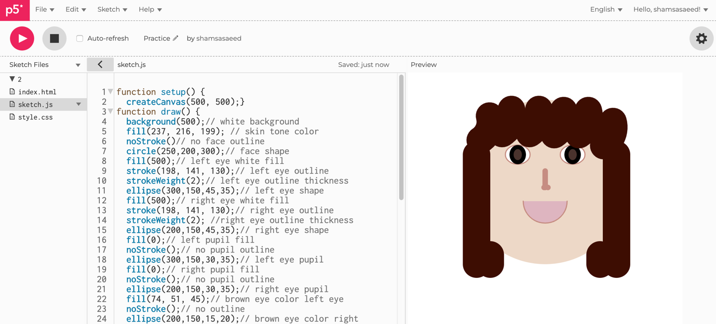<https://editor.p5js.org/shamsasaeed/sketches/SkZqtFPFJ>

